Project Planning Phase
Project Planning Template – Product Backlog, Sprint Planning, Stories, Story Points
Date | 15 February 2025
Team ID | SWTID-2026-7028
Project Name | Implement Client Script & UI Policy (Incident)
Maximum Marks | 5 Marks

Product Backlog, Sprint Schedule, and Estimation
Project objective: Implement Client Scripts and UI Policies on the ServiceNow Incident form to improve user experience, enforce field behavior, and reduce incorrect data entry. The implementation dynamically controls form fields based on user actions and incident conditions without requiring the form to be submitted.
Sprint | Functional Requirement (Epic) | User Story Number | User Story / Task | Story Points | Priority | Team Members
Sprint-1 | Incident Form Setup | USN-1 | As a ServiceNow user, I can access and configure the Incident form fields required for the project. | 2 | High
Sprint-1 | Client Script | USN-2 | As a user, when Impact changes to High, Urgency is automatically set to High without submitting the form. | 3 | High
Sprint-1 | Client Script | USN-3 | As a user, I receive an informational message when the Client Script automatically sets Urgency to High. | 2 | Medium
Sprint-2 | UI Policy | USN-4 | As a user, Incident fields dynamically become mandatory, visible, or read-only according to defined incident conditions. | 3 | High
Sprint-2 | UI Policy | USN-5 | As a user, field behavior changes immediately when the relevant Incident condition is met, without form submission. | 2 | High
Sprint-2 | Validation & Testing | USN-6 | As a project team member, I can verify Client Scripts and UI Policies across different Incident conditions. | 3 | High
Sprint-3 | Integration & Refinement | USN-7 | As a project team member, I can refine field behavior to reduce incorrect or incomplete Incident data entry. | 2 | Medium
Sprint-3 | Documentation | USN-8 | As a stakeholder, I can understand the configuration, workflow, and expected behavior of the Client Scripts and UI Policies. | 2 | Medium
Sprint-3 | Final Verification | USN-9 | As a project team member, I can perform final regression testing and confirm that dynamic form behavior works as expected. | 3 | High

Project Tracker, Velocity & Burndown Chart
Sprint | Total Story Points | Duration | Sprint Start Date | Sprint End Date (Planned) | Story Points Completed | Sprint Release Date (Actual)
Sprint-1 | 7 | 6 Days | 24 Feb 2025 | 01 Mar 2025 | 7 | 01 Mar 2025
Sprint-2 | 8 | 6 Days | 03 Mar 2025 | 08 Mar 2025 | 8 | 08 Mar 2025
Sprint-3 | 7 | 6 Days | 10 Mar 2025 | 15 Mar 2025 | 7 | 15 Mar 2025

Velocity
The planned workload is 22 story points across three sprints. Based on the planned six-day sprint duration, the average planned velocity is approximately 7.3 story points per sprint, or about 1.22 story points per day.
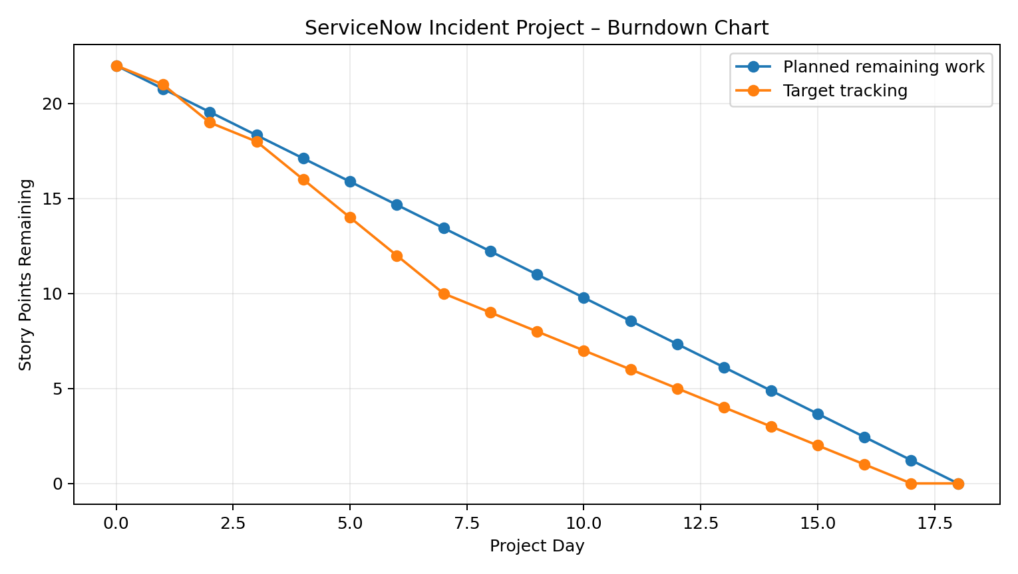
Figure 1: Burndown chart for the ServiceNow Incident Client Script and UI Policy project
Burndown Chart
A burndown chart represents work remaining against project time. For this project, the tracked work is measured in story points covering Incident form setup, Client Scripts, UI Policies, validation, integration, documentation, and final verification.
Project Scope Summary
• Client Scripts: dynamically respond to Incident field changes, including automatically setting Urgency when Impact is High.
• UI Policies: dynamically control field visibility, mandatory status, and read-only behavior based on Incident conditions.
• User Experience: provide immediate field behavior and feedback without requiring the Incident form to be submitted.
• Data Quality: reduce incorrect or incomplete Incident data entry through dynamic client-side controls.
• Testing: verify behavior across relevant Incident conditions and perform final regression testing.
References
Atlassian Agile Project Management and Scrum planning references from the original template.
Source project statement: User-provided project description for ServiceNow Incident Client Scripts and UI Policies.

